Tentative List of Speakers for the Conference:
- Prof. A.A. Kazmi
Civil Engineering Department
Indian Institute of Technology, Roorkee
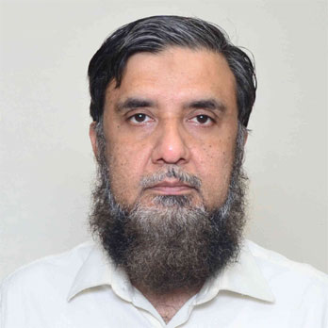

- Prof. B.J. Alappat
Department of Civil Engineering
Indian Institute of Technology, Delhi
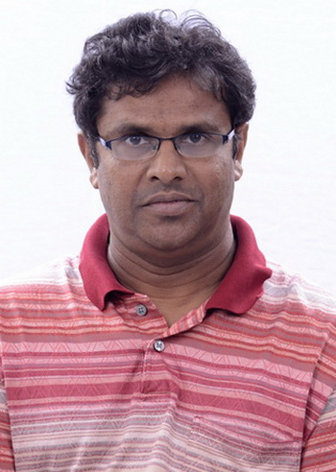

- Dr. S Venkata Mohan
Director
CSIR National Environmental Engineering Research Institute, Nagpur
Indian Institute of Chemical Technology
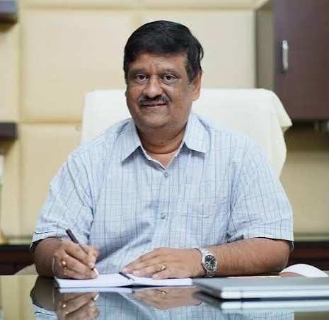
- Prof. Aki Sebastian Ruhl
Professor for Water Treatment
Technische Universität, Berlin, Germany
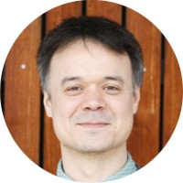

- Prof. Fumitake Nishimura
Department of Environmental Engineering
Kyoto University, Japan
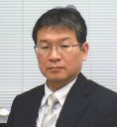

- Prof. Makarand Madhao Ghangrekar
Civil Engineering Department
Indian Institute of Technology, Kharagpur
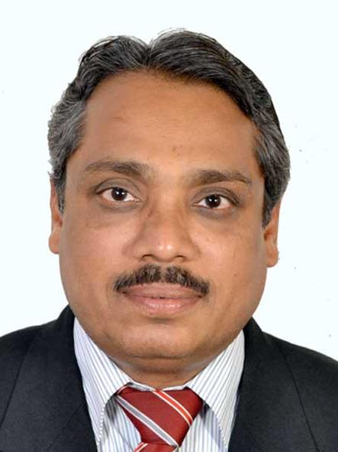

- Prof. B.K. Dubey
Civil Engineering Department
Indian Institute of Technology, Kharagpur
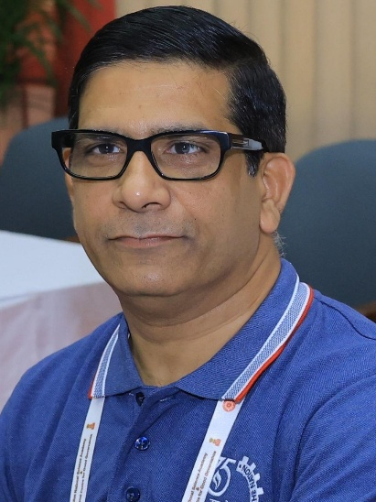
- Prof. R.R. Dash
School of Infrastructure
Indian Institute of Technology, Bhubaneswar
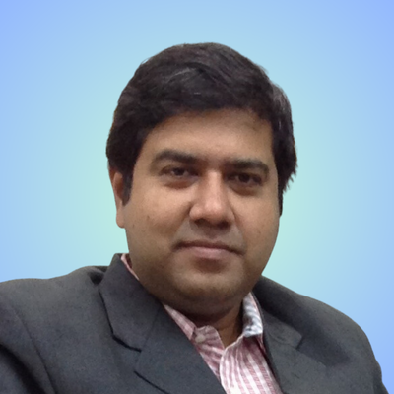

- Prof. Anurag Garg
Environmental Science and Engineering Department
Indian Institute of Technology, Bombay
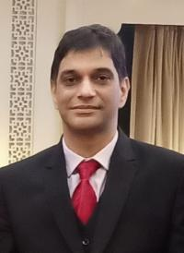

- Dr. Sonil Nanda
Assistant Professor
Department of Engineering
Faculty of Agriculture
Dalhousie University, Canada
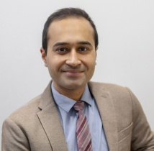
- Dr. Mayur Shirish Jain
Associate Professor
Department of Civil Engineering
Indian Institute of Technology, Indore

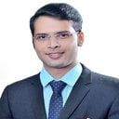

- Dr. Daya Pandey
Assistant Professor
School of Mechanical Engineering
University of Leeds, United Kingdom
